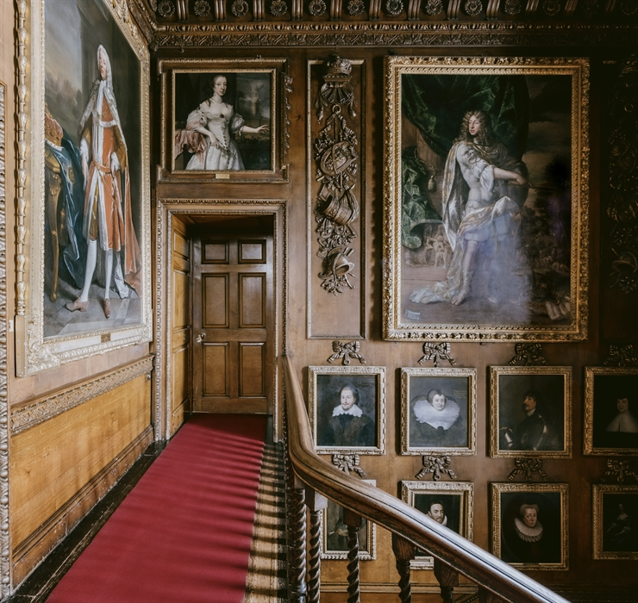
Interpreting historic houses, spaces, environments
Catalyst training and networking event for SGSAH PhD students
Monday 28th April 2025
Location: Blair Castle, Pitlochry, Perthshire, PH18 5TL
Timing: Arrival 0930 for 0950 start, concluding 1620.

What to bring:
- Laptop
- Notebook / pens / pencils (see Situated Writing exercise requirements)
- Indoor / outdoor clothing (we will be outside for part of the day)
- N.B. Mobile signal may be patchy.


 | 

Draft Programme
0930 | Arrival, refreshments & networking
0950 | Introductions – Ian Baxter and Helen McCormack
1000 | Helen McCormack (GSA) – historic houses and interiors
1045 | Haitang Zhang (GSA Doctoral student) - House museums as primary research
1100 | Focus session on archives/collections of Atholl Estates – Keren Guthrie (Atholl Estates)
1200 | Working Lunch and networking
1245 | Focus session on wider estate history, garden and land management – Chris Dingwall
1345 | Situated writing exercise (see instructions below – bring relevant materials!)
1410 | Estates and world connections - Craig Thomas (Buccleuch Living Heritage Trust)
1445 | Putting heritage to work: historic houses in the 21st century - Sarah Roller (Historic Houses Assoc)
1530 | Historic houses - experiential and career contexts – Ian Baxter (Heriot-Watt University)
1600 | Conclusions – country houses as complex research environments
1620 | Ends

Situated writing exercise
During the day we will invite students to choose a specific site (this might be a room, corridor, window seat, door frame or threshold, garden path or wall, or a piece of furniture, sculpture or painting, textile or surface) related to the house and grounds and write 800 words as a ‘situated writing’ exercise. The writing can be carried out in pencil/pen on paper, in a notebook, a laptop, phone or tablet. Students are also welcome to draw sketches, take photographs and make short video/films. This exercise is centred on the ideas of Jane Rendell, in her work, ‘Sites, Situations, and Other Kinds of Situatedness’: https://www.janerendell.co.uk/wp-content/uploads/2021/12/Log48_Rendell.pdf
The situated writing exercise is an opportunity to reflect on the historical site of Blair Castle and Estate, its architecture, rich interior decoration and its ‘landedness’, as an ancient Scottish estate. Using Rendell’s description of situatedness, ‘as the location of space and a set of circumstances bounded in time – the conditions of a particular instant, a moment, an event’, we ask students to consider individual presences within Blair’s interiors or landscape and write in response to such experiences, informed by historical accounts of these spaces and physical encounters with the site over the course of the day.

Workshop preparation
Some of the speakers at the workshop have provided some pre-reading / relevant resources which researchers may find useful to access in advance of the day.

Helen McCormack (GSA) - Recommended Readings
Gaston Bachelard, The Poetics of Space, chapter 3, ‘Drawers, Chests and Wardrobes’, Penguin books, 1964, pp. 95-109.
John Bonehill, ‘Scotland’s Prospects’ in Old Ways New Roads: Travels in Scotland 1720-1832, edited by John Bonehill, Anne Dulau Beveridge and Nigel Leask, Birlinn Press, in association with the Hunterian Museum and University of Glasgow, pp. 126-145.
Viccy Coltman, Art and Identity in Scotland: A Cultural History from the Jacobite Rising of 1745 to Walter Scott, Cambridge University Press, 2019, pp. 62-103.
Christopher Dingwall, ‘Roads, Bridges and Designed Landscapes on the Highland Circuit’, in Old Ways New Roads: Travels in Scotland 1720-1832, edited by John Bonehill, Anne Dulau Beveridge and Nigel Leask, Birlinn Press, in association with the Hunterian Museum and University of Glasgow, pp. 112-125.
Mark Girouard, Life in the English Country House: A Social and Architectural History, chapter 7, ‘The Social House’, Yale University Press, 1978, pp. 181-212.
Frederick Albritton Jonsson, Enlightenment’s Frontier: The Scottish Highlands and the Origins of Environmentalism, chapter 2, ‘Natural History and Civil Cameralism’, Yale University Press, 2013, pp. 43-68.
Sam Johnson-Schlee, Living Rooms, Peninsula Press, 2022.

Keren Guthrie (Atholl Estates) – recommended readings

The Atholl Chronicles and Tullibardine families https://digital.nls.uk/histories-of-scottish-families/archive/95221070 , Ballantyne Press, 1896, (1) Front cover – (28) page 6.

Elizabeth Lomas, A Guide to the retention of Modern Records on Landed Estates, chapter vii, ‘Public Access and Marketing Recors’, Historic House Archivisit Group, 2007, pp. 60-61

Sarah Roller (Historic Houses) – recommended readings
Saving Country Houses and their Collections in the Twentieth and Twenty-First Centuries (Ben Cowell) https://www.artandthecountryhouse.com/essays/essays-index/saving-country-houses-and-their-collections-in-the-twentieth-and-twenty-first-centuries
‘My 12th-century castle is at risk under Labour’s tax raid – I’m so angry' https://www.telegraph.co.uk/money/property/12th-century-castle-might-not-survive-labour-government/
VIDEO: Changing Times, Valuing History https://www.historichouses.org/changing-times-valuing-history-historic-houses-for-the-21st-century/

Craig Thomas (Buccleuch Living Heritage Trust) – recommended readings
D. Cannadine, Aspects of Aristocracy, (London: Yale University Press, 1994), Conclusion, pp. 242-245.
D. Cannadine, The Decline and Fall of the British Aristocracy, (London: Yale University Press, 1990), Prologue, pp. 1-32.
T. Dooley, Burning the Big House, (London: Yale University Press, 2023). Chapter 9: The End of Revolution? pp. 239-283.

Ian Baxter (Heriot-Watt University) – recommended readings
Our past our future – the strategy for Scotland’s historic environment https://www.historicenvironment.scot/archives-and-research/publications/publication/?publicationId=79204155-9eb2-4d29-ab14-aff200ec2801
Scotland Outlook 2030 – responsible tourism for a sustainable future https://scottishtourismalliance.co.uk/scotland-outlook-2030-overview/
Robson, E.M. (2025) Assessing the social values of heritage. Routledge, Abingdon.

